

Student Name | <<enter Full Name >>
SRN No | <<enter SRN No >>
Roll No | <<Enter Roll No>>
Program | <<AIDS / Computer Engg.>>
Year | Third Year
Division | <<Enter division>>
Subject | Computer Network Laboratory (BTECCE21506)
Assignment No | Four

Assignment Number - 04

Title : Configuration of router by using router commands and implementation of static routing

Problem Statement Using a Network Simulator (e.g. packet tracer) Configure routers for static routing

Theory :
Router – Router is a network device that allows you to direct data traffic to an appropriate destination. Router maintain routing table that contain IP addresses of computers over the network. A router has different components that enable proper functioning.
Cisco IOS supports various command modes, among those followings are the main command modes.
• User EXEC Mode
• Privileged EXEC Mode
• Global Configuration Mode
• Interface Configuration Mode
• Sub Interface Configuration Mode
• Setup Mode
Mode | Prompt | Command to enter | Command to exit
User EXEC | Router > | Default mode after booting. Login  with password, if configured. | Use exit command
Privileged EXEC | Router # | Use enable command from user  exec mode | Use exit command
Global | Router(config)# | Use configure terminal command  from privileged exec mode | Use exit command
Configuration | Router(config)# | Use configure terminal command  from privileged exec mode | Use exit command
Interface | Router(config-if)# | Use interface | Use exit command to  return in global configuration mode
Configuration | Router(config-if)# | type number command from  global configuration mode | Use exit command to  return in global configuration mode
Sub-Interface | Router(config-subif) | Use interface type sub interface  numbercommand from global configuration mode or interface configure mode | Use exit to return  previous mode. Use end command to return in privileged exec mode.
Configuration | Router(config-subif)

Some important router Command
Command |  |  | Description
Router(config)#interface serial 0/0/0 |  |  | Enter into serial interface 0/0/0  configuration mode
Router(config-if)#description | Connected | to | Optional command. It set description on
Interface |  |  | interface that is locally significant
Router(config-if)#ip address 10.0.0.1 |  |  | Assigns address and subnet mask to  Interface
255.0.0.0 |  |  | Assigns address and subnet mask to  Interface
Router(config-if)#clock rate 64000 |  |  | DCE side only command. Assigns a clock  rate for the interface
Router(config-if)#bandwidth 64 |  |  | DCE side only command. Set bandwidth for  the interface.
Router(config-if)#no shutdown |  |  | Turns interface on

Configuration of static Routing
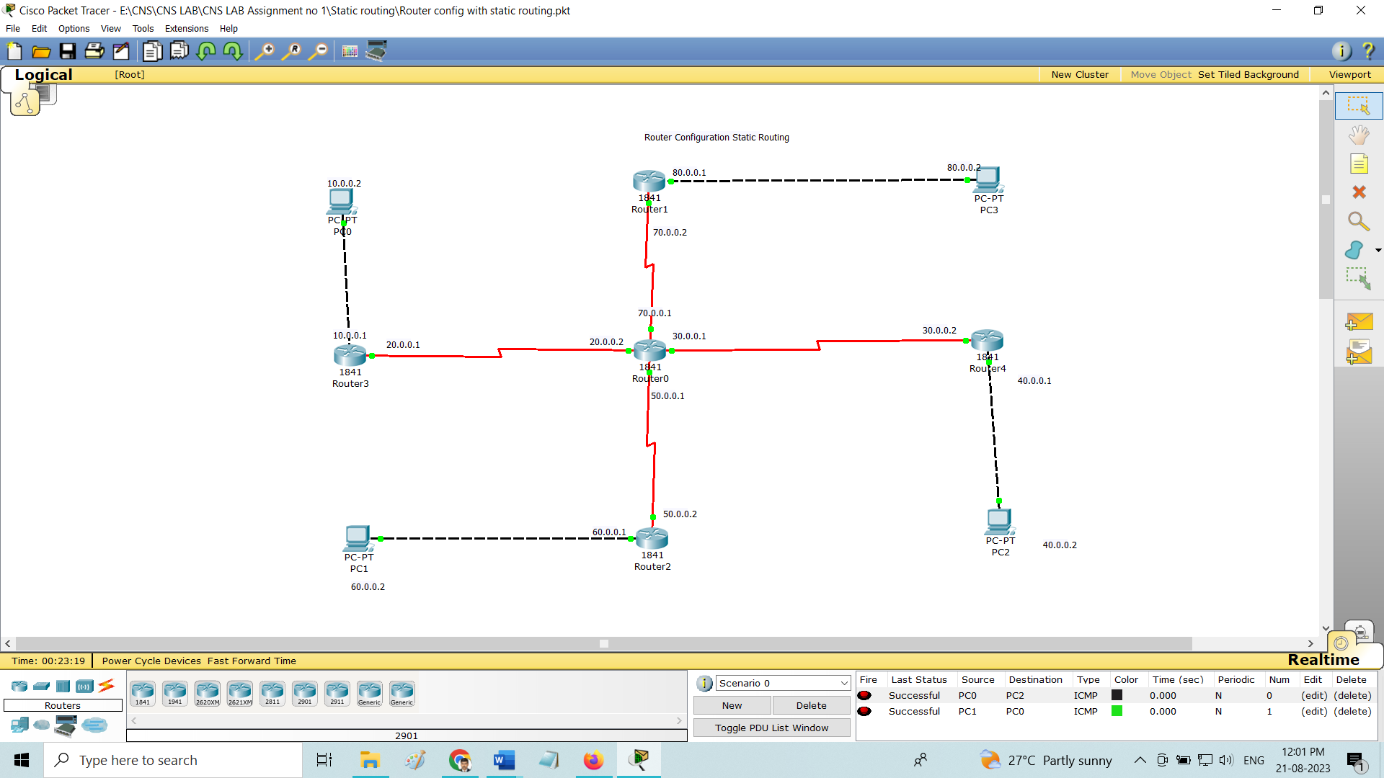

Code
Basic Router Configuration – Static Routing
Router0 Configuration
Router>enable
Router#configure terminal
Enter configuration commands, one per line. End with CNTL/Z.
Router(config)#interface Serial0/1/0
Router(config-if)#ip address 20.0.0.2 255.0.0.0
Router(config-if)#no shutdown
Router(config-if)#
%LINK-5-CHANGED: Interface Serial0/1/0, changed state to up

%LINEPROTO-5-UPDOWN: Line protocol on Interface Serial0/1/0, changed state to up

Router(config-if)#exit
Router(config)#interface Serial0/0/0
Router(config-if)#ip address 30.0.0.1 255.0.0.0
Router(config-if)#no shutdown
Router(config-if)#
%LINK-5-CHANGED: Interface Serial0/0/0, changed state to up

Router(config-if)#exit
Router(config)#interface Serial0/0/1
Router(config-if)#
%LINEPROTO-5-UPDOWN: Line protocol on Interface Serial0/0/0, changed state to up
ip address 50.0.0.1 255.0.0.0
Router(config-if)#no shutdown
Router(config-if)#
%LINK-5-CHANGED: Interface Serial0/0/1, changed state to up

Router(config-if)#exit
Router(config)#interface Serial0/1/1
Router(config-if)#ip address 70.0.0.1 255.0.0.0
Router(config-if)#
%LINEPROTO-5-UPDOWN: Line protocol on Interface Serial0/0/1, changed state to up
no shutdown
Router(config-if)#
%LINK-5-CHANGED: Interface Serial0/1/1, changed state to up

%LINEPROTO-5-UPDOWN: Line protocol on Interface Serial0/1/1, changed state to up
Router(config)#ip route 10.0.0.0 255.0.0.0 20.0.0.1
Router(config)#ip route 80.0.0.0 255.0.0.0 70.0.0.2
Router(config)#ip route 40.0.0.0 255.0.0.0 30.0.0.2
Router(config)#ip route 60.0.0.0 255.0.0.0 50.0.0.2
Router#show ip route
Codes: C - connected, S - static, I - IGRP, R - RIP, M - mobile, B - BGP
D - EIGRP, EX - EIGRP external, O - OSPF, IA - OSPF inter area
N1 - OSPF NSSA external type 1, N2 - OSPF NSSA external type 2
E1 - OSPF external type 1, E2 - OSPF external type 2, E - EGP
i - IS-IS, L1 - IS-IS level-1, L2 - IS-IS level-2, ia - IS-IS inter area
* - candidate default, U - per-user static route, o - ODR
P - periodic downloaded static route

Gateway of last resort is not set

S 10.0.0.0/8 [1/0] via 20.0.0.1
C 20.0.0.0/8 is directly connected, Serial0/1/0
C 30.0.0.0/8 is directly connected, Serial0/0/0
S 40.0.0.0/8 [1/0] via 30.0.0.2
C 50.0.0.0/8 is directly connected, Serial0/0/1
S 60.0.0.0/8 [1/0] via 50.0.0.2
C 70.0.0.0/8 is directly connected, Serial0/1/1
S 80.0.0.0/8 [1/0] via 70.0.0.2
Router#

Router1 Configuration
Router>enable
Router#configure terminal
Enter configuration commands, one per line. End with CNTL/Z.
Router(config)#interface FastEthernet0/0
Router(config-if)#ip address 80.0.0.1 255.0.0.0
Router(config-if)#no shutdown

Router(config-if)#
%LINK-5-CHANGED: Interface FastEthernet0/0, changed state to up

%LINEPROTO-5-UPDOWN: Line protocol on Interface FastEthernet0/0, changed state to up

Router(config-if)#exit
Router(config)#interface Serial0/0/0
Router(config-if)#ip address 70.0.0.2 255.0.0.0
Router(config-if)#no shutdown
Router(config-if)#
Router(config)#ip route 10.0.0.0 255.0.0.0 70.0.0.1
Router(config)#ip route 20.0.0.0 255.0.0.0 70.0.0.1
Router(config)#ip route 30.0.0.0 255.0.0.0 70.0.0.1
Router(config)#ip route 40.0.0.0 255.0.0.0 70.0.0.1
Router(config)#ip route 50.0.0.0 255.0.0.0 70.0.0.1
Router(config)#ip route 60.0.0.0 255.0.0.0 70.0.0.1

Router2 Configuration
Router>enable
Router#configure terminal
Enter configuration commands, one per line. End with CNTL/Z.
Router(config)#interface FastEthernet0/0
Router(config-if)#ip address 60.0.0.1 255.0.0.0
Router(config-if)#no shutdown

Router(config-if)#
%LINK-5-CHANGED: Interface FastEthernet0/0, changed state to up

%LINEPROTO-5-UPDOWN: Line protocol on Interface FastEthernet0/0, changed state to up

Router(config-if)#exit
Router(config)#interface Serial0/0/0
Router(config-if)#no shutdown
Router(config-if)#exit
Router(config)#interface Serial0/0/0
Router(config-if)#ip address 50.0.0.2 255.0.0.0
Router(config-if)#
Router(config)#ip route 10.0.0.0 255.0.0.0 50.0.0.1
Router(config)#ip route 20.0.0.0 255.0.0.0 50.0.0.1
Router(config)#ip route 30.0.0.0 255.0.0.0 50.0.0.1
Router(config)#ip route 40.0.0.0 255.0.0.0 50.0.0.1
Router(config)#ip route 70.0.0.0 255.0.0.0 50.0.0.1
Router(config)#ip route 80.0.0.0 255.0.0.0 50.0.0.1
Router(config)#

Router3 Configuration
Router>enable
Router#configure terminal
Enter configuration commands, one per line. End with CNTL/Z.
Router(config)#interface FastEthernet0/0
Router(config-if)#ip address 10.0.0.1 255.0.0.0
Router(config-if)#no shutdown

Router(config-if)#
%LINK-5-CHANGED: Interface FastEthernet0/0, changed state to up

%LINEPROTO-5-UPDOWN: Line protocol on Interface FastEthernet0/0, changed state to up

Router(config-if)#exit
Router(config)#interface Serial0/0/0
Router(config-if)#ip address 20.0.0.1 255.0.0.0
Router(config-if)#clock rate 64000
Router(config-if)#no shutdown
Router(config-if)#
Router(config)#ip route 30.0.0.0 255.0.0.0 20.0.0.2
Router(config)#ip route 40.0.0.0 255.0.0.0 20.0.0.2
Router(config)#ip route 50.0.0.0 255.0.0.0 20.0.0.2
Router(config)#ip route 60.0.0.0 255.0.0.0 20.0.0.2
Router(config)#ip route 70.0.0.0 255.0.0.0 20.0.0.2
Router(config)#ip route 80.0.0.0 255.0.0.0 20.0.0.2
Router(config)#
Router#
%SYS-5-CONFIG_I: Configured from console by console

Router#
Router#show ip route
Codes: C - connected, S - static, I - IGRP, R - RIP, M - mobile, B - BGP
D - EIGRP, EX - EIGRP external, O - OSPF, IA - OSPF inter area
N1 - OSPF NSSA external type 1, N2 - OSPF NSSA external type 2
E1 - OSPF external type 1, E2 - OSPF external type 2, E - EGP
i - IS-IS, L1 - IS-IS level-1, L2 - IS-IS level-2, ia - IS-IS inter area
* - candidate default, U - per-user static route, o - ODR
P - periodic downloaded static route

Gateway of last resort is not set

C 10.0.0.0/8 is directly connected, FastEthernet0/0
C 20.0.0.0/8 is directly connected, Serial0/0/0
S 30.0.0.0/8 [1/0] via 20.0.0.2
S 40.0.0.0/8 [1/0] via 20.0.0.2
S 50.0.0.0/8 [1/0] via 20.0.0.2
S 60.0.0.0/8 [1/0] via 20.0.0.2
S 70.0.0.0/8 [1/0] via 20.0.0.2
S 80.0.0.0/8 [1/0] via 20.0.0.2

Router4 Configuration
Router>enable
Router#configure terminal
Enter configuration commands, one per line. End with CNTL/Z.
Router(config)#interface FastEthernet0/0
Router(config-if)#ip address 40.0.0.1 255.0.0.0
Router(config-if)#no shutdown

Router(config-if)#
%LINK-5-CHANGED: Interface FastEthernet0/0, changed state to up

%LINEPROTO-5-UPDOWN: Line protocol on Interface FastEthernet0/0, changed state to up

Router(config-if)#exit
Router(config)#interface Serial0/0/0
Router(config-if)#ip address 30.0.0.2 255.0.0.0
Router(config-if)#clock rate 64000
This command applies only to DCE interfaces
Router(config-if)#no shutdown
Router(config-if)#do write
Building configuration...
[OK]
Router(config-if)#
Router#config t
Enter configuration commands, one per line. End with CNTL/Z.
Router(config)#ip route 10.0.0.0 255.0.0.0 30.0.0.1
Router(config)#ip route 20.0.0.0 255.0.0.0 30.0.0.1
Router(config)#ip route 50.0.0.0 255.0.0.0 30.0.0.1
Router(config)#ip route 60.0.0.0 255.0.0.0 30.0.0.1
Router(config)#ip route 70.0.0.0 255.0.0.0 30.0.0.1
Router(config)#ip route 80.0.0.0 255.0.0.0 30.0.0.1

Conclusion : <<Write Conclusion in your own words. Write about what you learn from assignment>>

